NoodleTools Tutorial – Middle School

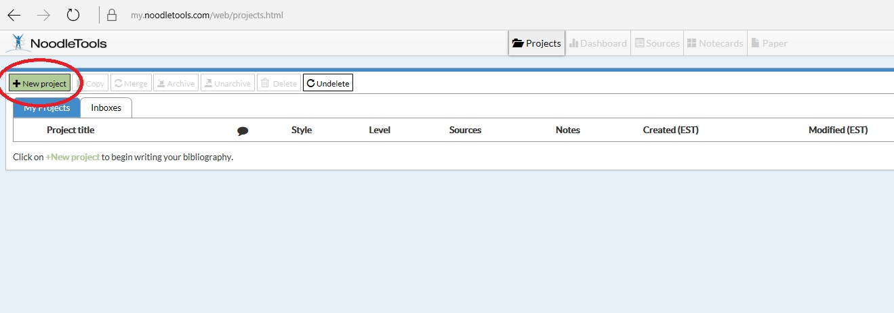
- Once signed in to NoodleTools, you will be brought to this home page. From here, click on the “New Project” button.

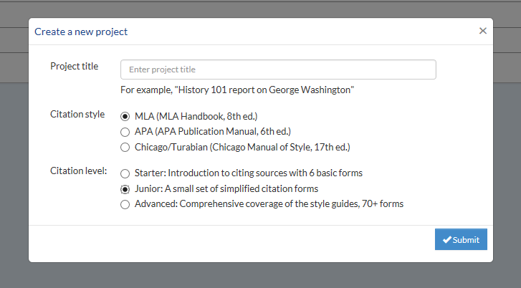
- Enter a project title, select ‘MLA’, select ‘Junior’, and then submit

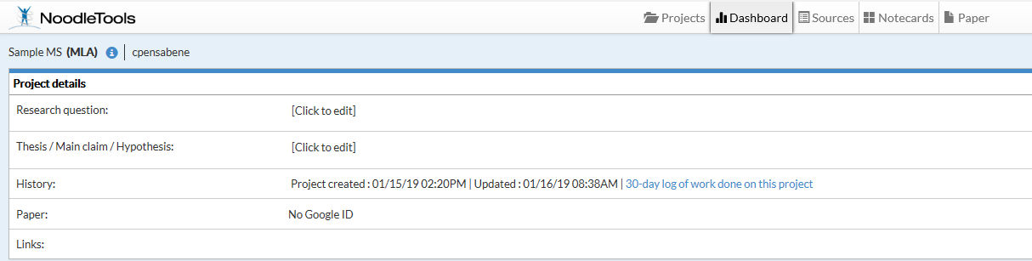
- Once a project has been started, you will be brought to your ‘dashboard.’ On your dashboard, you can enter your research question and your thesis. To add sources, go to the page at the top titled ‘sources’.

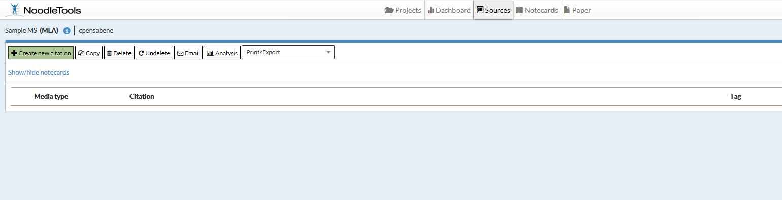
- To add a new citation, click the green ‘create new citation’ button.

- NoodleTools will then prompt you to select the type of file you are using. Select the type of file from the choices listed.
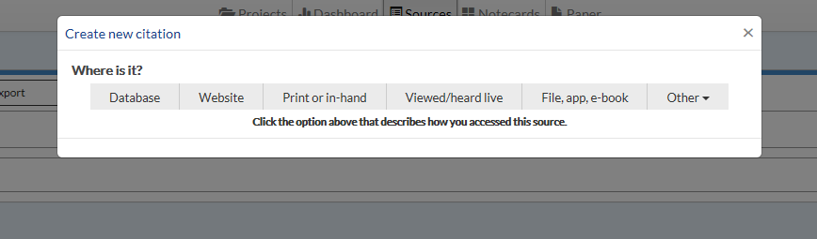

- Next, fill out the citation information that you have for the source. If you are using a book, you can enter the ISBN. This will automatically fill out the required fields.

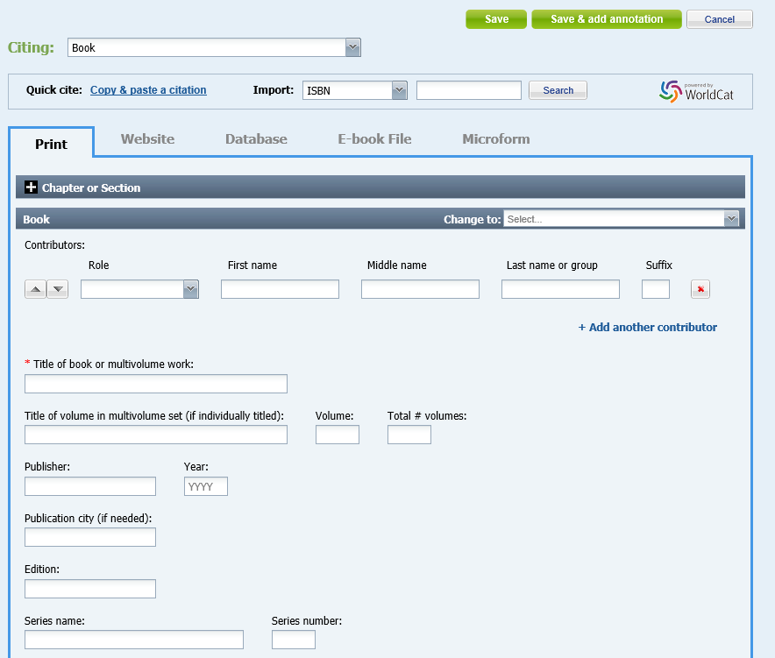

Once your citation is complete, select ‘save’.

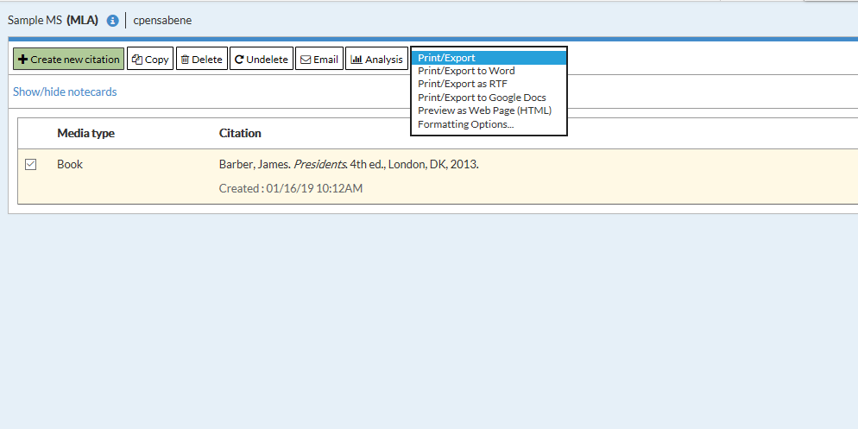
- After you select ‘save’, you will be brought back to your sources page. Continue adding sources until you have finished your works cited. When finished, check the box next to the sources that you want on your works cited.

- Finally, use the ‘print/export’ button and select where you would like your works cited to export.

