NoodleTools Tutorial – Lower School

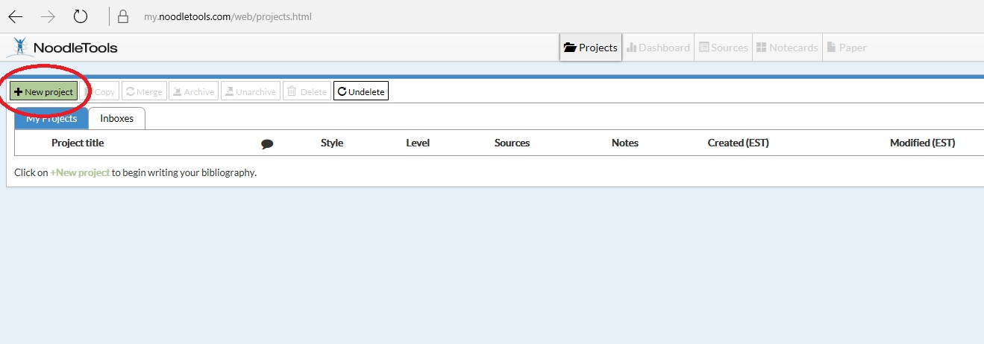
- After you sign in to NoodleTools, click on the ‘New Project’ button

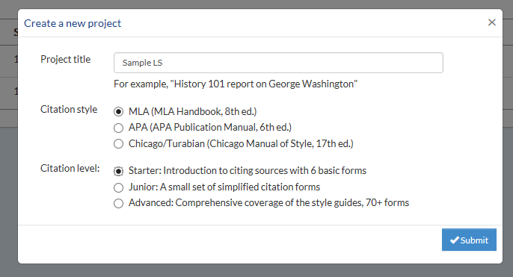
- Enter a title, select MLA, and Starter.

- Then, click on the ‘sources’ button.
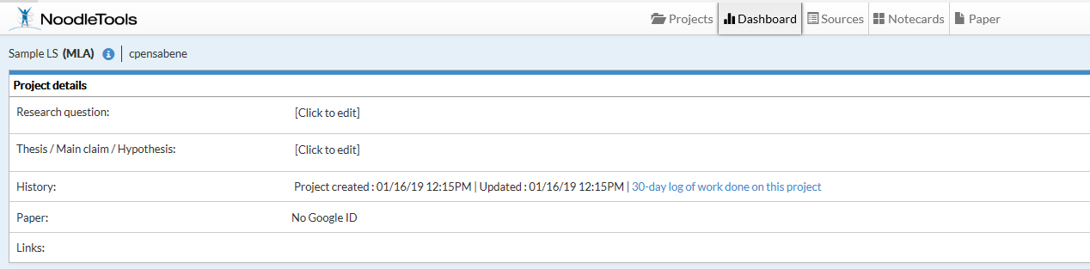

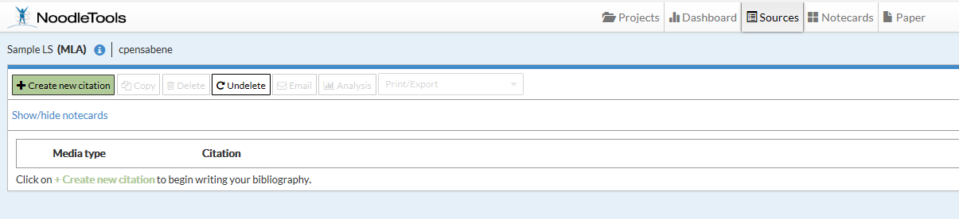
- Next, press ‘create new citation.’

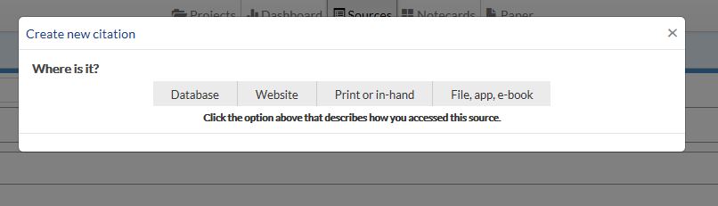
- Choose the source you used. There are choices under each title.

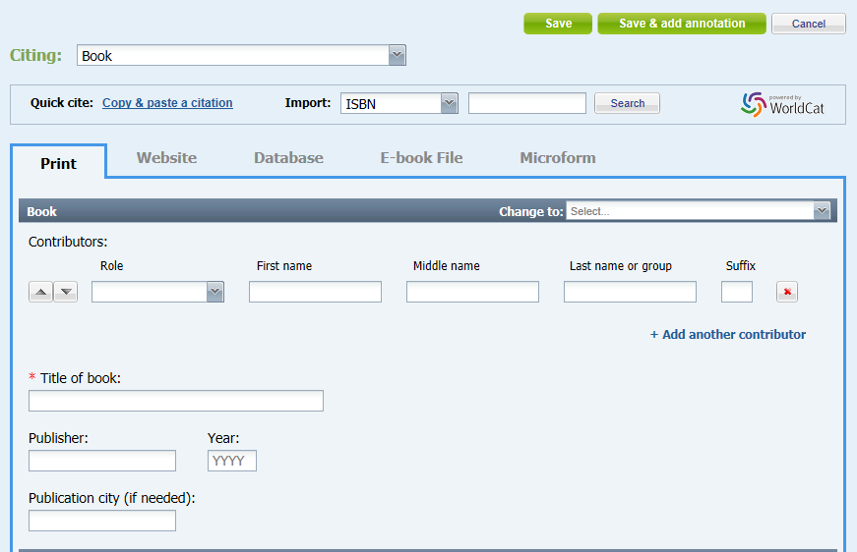
- Enter the information from your source. If you are using a book, you can enter the ISBN. An ISBN is the number from the barcode on the back of the book. When you’re done, press ‘save.’

- After you press ‘save,’ you can add more sources until you are done.

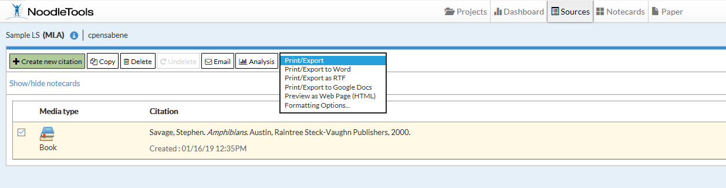
- When you are done adding sources, make sure the boxes next to each source have a check mark. Then, press Print/Export and choose where to open your works cited.

